

Project: Campus Service Request Management System
Unit: IS305 Object-Oriented Programming, Divine Word University
Assessment: AT3 Major Project
Student Name: Abigail ANDILI
Student ID: 240151
Due Date: 02/10/2026 Week 14
This document combines all five required submission documents:
- Requirements Document
- UML and System Design
- Technical Documentation
- Test Report

CONTENTS
1. Requirement Document 4
1. Project Background 4
2. Problem Statement 4
3. Project Objectives 4
4. Project Scope 5
4.1 In scope 5
4.2 Out of scope 5
5. Actors and User Roles 5
6. Functional Requirements 6
6.1 Users 6
6.2 Submitting and managing requests 6
6.3 Viewing, searching, filtering and sorting 7
6.4 Workflow and roles 7
6.5 Polymorphism, persistence, audit and reports 7
6.6 Console interface 8
7. Non-Functional Requirements 9
8. Assumptions and Limitations 9
9. User Stories 10
2. UML and System Design 11
1. Case Diagram 11
2. Complete Class Diagram 13
2.1 Explanation of class relationships 13
2.2 Separation of responsibilities 14
3. Status Lifecycle (state diagram) 14
4. Sequence Diagram: Submitting a Request 15
5. Sequence Diagram: Assigning a Technician 16
6. Sequence Diagram: Resolving and Closing a Request 17
3. Technical Documentation 17
1. Overview 18
2. Project Folder Structure 18
3. Responsibility of Each Class 19
4. Where Encapsulation Is Used 20
5. Inheritance and Constructor Chaining 20
6. Where Overriding and Polymorphism Are Used 21
6.1 Abstract-style base class 21
6.2 Overriding 22
6.3 Polymorphism 23
7. How the Request Workflow Is Controlled 23
8. How Validation and Errors Are Handled 24
9. How JSON Data Is Stored and Restored 26
9.1 Files 26
9.2 Saving 27
9.3 Loading and restoring objects 27
10. How Tests Are Organised 28
11. Known Limitations and Future Improvements 28
4. Test Report 29
1. Test Environment 29
2. Summary 29
3. Automated Tests 30
3.1 Pass tests (test/pass.test.js) 30
3.2 Credit tests (test/credit.test.js) 31
3.3 Distinction tests (test/distinction.test.js) 32
4. Manual Console Tests 33
5. Design Consistency Check 38
6. Issues Found During Testing 38
7. How to Repeat These Tests 39
8. Evidence Files 39

NOTE: How to read this document. Each functional requirement is tagged with the achievement level that delivers it: [P] Pass, [C] Credit, [D] Distinction. Update the tags and wording if your final scope changes.

1. Requirement Document

1. Project Background
Divine Word University (DWU) students and staff regularly need help with campus services: broken ICT equipment or Wi-Fi, damaged facilities, cleaning needs and other general problems. At present these problems are reported by telephone, informal conversation or handwritten notes.
These informal methods leave no reliable record. Nobody can easily see which problems have been reported, who is responsible for fixing them, how far the work has progressed, or whether the requester agrees the problem has been resolved.
This project builds a Node.js console application that records, assigns, processes and monitors campus service requests. It is developed with JavaScript classes and object-oriented design principles, and uses no database (objects and arrays first, then JSON files for persistence).

2. Problem Statement
Campus service problems are reported through untracked channels. As a result requests are lost or duplicated, responsibility is unclear, progress cannot be monitored, and managers cannot measure workload or response times. The campus needs a single system in which every request is recorded, moves through a controlled workflow, is assigned to a responsible person, and leaves an auditable history.

3. Project Objectives
NO# | Objective
O1 | Let registered users submit valid campus service requests in four categories.
O2 | Store and manage users and requests with well-designed classes, encapsulation and validation.
O3 | Let requesters view, update and cancel their own requests, and prevent them touching anyone else's.
O4 | Provide a controlled workflow (Submitted, Reviewed, Assigned, In Progress, Resolved, Closed) with role-based permissions.
O5 | Represent different request types with inheritance and polymorphism.
O6 | Keep a history of every request and an audit trail of important actions.
O7 | Save data to JSON files and restore it as correct objects when the program restarts.
O8 | Give administrators management reports built with JavaScript array methods.
O9 | Verify the system with at least 10 automated tests and a documented test report.

4. Project Scope

4.1 In scope
- Node.js console application (menu driven).
- Registering users and four user roles (requester, Service Officer, Technician, Administrator).
- Four request categories: ICT Support, Facilities Maintenance, Cleaning and Sanitation, General Campus Service.
- Submitting, viewing, searching, filtering, sorting, updating and cancelling requests.
- Review, priority setting, technician assignment, work progress, resolution and closure.
- Request history, audit log and management reports.
- JSON file storage using Node.js fs/promises.
- Automated tests with the built-in Node.js test runner.
- Documentation: requirements, UML design, technical documentation, user guide, test report.

4.2 Out of scope
- Any database (MongoDB, Mongoose, MySQL, SQLite or similar).
- Graphical or web user interface.
- Real authentication, passwords or encryption.
- Email/SMS notifications, file attachments or real-time updates.
- Real institutional data (only simulated data is used).
- Multiple users using the system at the same time.

5. Actors and User Roles
Actor | Description | Main responsibilities
Student Requester | A DWU student (programme, year level). | Submit requests, view progress, update and cancel own submitted requests.
Staff Requester | A DWU staff member (department). | Same as Student Requester.
Service Officer | Staff member in a service section who manages incoming requests. | Review requests, set priority, assign Technicians, verify completion and close requests, search/filter/sort.
Technician | Skilled worker with a technical specialty. | View assigned requests, start work, add progress notes, resolve requests.
System Administrator | Oversees the system. | Review system records, audit history and management reports.
Storage (system) | JSON data files (secondary, non-human actor). | Keep users, requests, history and audit data between runs.
An Administrator is a registered User with the user type Administrator.

6. Functional Requirements

6.1 Users
Requirement | Level
The system shall register a user with a user ID, first name, last name, email address and user type. | P
The system shall reject registration with a missing user ID, missing first or last name, invalid email address, unsupported user type or a duplicate user ID. | P
The system shall provide specialized user roles: StudentRequester (programme, year level), StaffRequester (department), ServiceOfficer (service section) and Technician (technical specialty), each built on the User base class. | C

6.2 Submitting and managing requests
Requirement | Level
A registered requester shall be able to submit a request with title, description, campus location, category and priority. The request receives a unique request ID and the default status Submitted. | P
The system shall reject a request with a missing title, description or location, an unsupported category, an unsupported priority, an unregistered requester or a duplicate request ID. | P
Categories shall be: ICT Support, Facilities Maintenance, Cleaning and Sanitation, General Campus Service. Priorities shall be: Low, Normal, High, Urgent. | P
The system shall support specialized requests carrying extra validated information: ICT (device type, system name, fault type, network impact), Maintenance (building, room number, hazard level, equipment affected), Cleaning (cleaning area, hygiene risk, service type, preferred service time) and General (service type, expected outcome). | C
A requester shall be able to update the details of their own request only while its status is Submitted. Updates are all-or-nothing. The category cannot be changed after submission (the category decides the request type); the requester must cancel and resubmit. | P
A requester shall be able to cancel their own request only while its status is Submitted. Cancelling another user's request, or a request already Cancelled, shall be rejected. | P

6.3 Viewing, searching, filtering and sorting
Requirement | Level
The system shall let users view a request by ID, view only their own requests, and view all requests. | P
The system shall search requests by text (ignoring case). | P
The system shall provide a count of requests by status. | P
The system shall filter requests by category, status, priority and assigned Technician, and sort them by date submitted and by priority. | C

6.4 Workflow and roles
Requirement | Level
Request status shall follow the permitted flow Submitted, Reviewed, Assigned, In Progress, Resolved, Closed. Cancelled is a final status. Invalid transitions shall be rejected. | C
Only a Service Officer may review a request and set its priority. | C
Only a Service Officer may assign a Technician. | C
Only the assigned Technician may start work, add progress notes and resolve the request. | C
Only a Service Officer may verify and close a Resolved request. | C
Every request shall keep a history array recording previous status, new status, action, actor ID or role, comment and date/time for each approved workflow action. | C

6.5 Polymorphism, persistence, audit and reports
Requirement | Level
Different request types shall be stored in one collection and processed through the same method calls (getRequestSummary(), calculatePriorityScore(), getTargetResolutionHours()), giving type-specific results. The base class shall throw a clear error if a subclass does not supply these methods. | D
The system shall store data in data/users.json, data/serviceRequests.json, data/requestHistory.json and data/auditLog.json; load existing records at start-up; create an empty array when a file does not exist; and save after every successful change. | D
File access shall be separated into repository classes; the console application shall not read or write JSON files directly. | D
Saved records shall be restored as the correct specialised objects (through a factory) that still support validation, overriding and polymorphism. | D
The system shall never save incomplete or invalid records and shall show clear file-reading and file-writing errors. | D
The system shall record an audit entry (audit ID, actor, action, request ID, description, date/time, outcome) for user registration, request creation, updates, priority changes, Technician assignment, status changes, cancellation, resolution and closure. | D
The system shall provide at least four management reports (target: nine) using filter(), map(), reduce() and sort(): requests by status, category and priority; urgent requests; overdue requests; requests assigned to each Technician; completed requests by Technician; average resolution time; and request volume by campus location. | D
The system shall include at least 10 automated tests using the Node.js test runner and temporary files. | D

6.6 Console interface
Requirement | Level
The console shall show the required Pass menu, options 1 to 10 (Register User, Submit Service Request, View Request by ID, View My Requests, View All Requests, Update My Request, Cancel My Request, Search Requests, View Request Summary, Exit). | P
Invalid input shall produce a clear message and the program shall continue running. | P
Later stages shall add menu options 11 upward (Service Officer, Technician, Filter and Sort, Administrator menus) without changing options 1 to 10. | C/D

7. Non-Functional Requirements
Category | Requirement
Usability | Prompts and menus shall be clear, numbered choices shall be accepted where a list is shown, and every error message shall say what is wrong and, where possible, what is allowed.
Reliability | Invalid input or a failed operation shall never crash the application; errors are caught and reported and the menu returns.
Data integrity | Updates are all-or-nothing; invalid or incomplete records are never stored or saved; identifiers are unique.
Maintainability | One class per file; separation of responsibilities (domain classes, manager, repositories, console); meaningful names and comments.
Extensibility | A new request type should need only a new subclass and a factory entry, not changes to the manager or console.
Portability | Runs on Node.js 18 or newer on Windows, macOS and Linux with no third-party dependencies.
Performance | Common operations (submit, search, report) should feel instant (target: under one second) for a few hundred requests.
Security and privacy | Only simulated data is used; no passwords, tokens or real institutional records are stored in code or data files; JSON files contain data only, never executable code.
Testability | Logic is separated from console input/output so it can be tested automatically; tests use temporary files and never overwrite the real data folder.
Auditability | Important actions are traceable through request history and the audit log.

8. Assumptions and Limitations
Assumptions
- The person using the console truthfully identifies themselves by entering their user ID (there is no login).
- The system clock supplies all dates and times.
- One person uses the application at a time, on one computer.
- A Service Officer, at least one Technician and an Administrator are registered before the workflow can be demonstrated.
- Request IDs are generated by the application in the form REQ001, REQ002 and so on.
Limitations
- No authentication or encryption: user IDs are trusted, JSON files are plain text.
- Console interface only; no notifications or attachments.
- JSON files are read and written whole, so the design suits small demonstration data sets, not large multi-user use.
- Simple email validation (format check only, no verification).
- One campus and one time zone are assumed.

9. User Stories
ID | User story | Acceptance criteria
US-01 | As a student or staff member, I want to register with my ID, name and email, so that I can submit service requests. | Valid details are accepted. A duplicate ID, missing name or invalid email is rejected with a clear message.
US-02 | As a requester, I want to submit a request with a title, description, location, category and priority, so that the problem is officially recorded. | The request gets a unique ID and status Submitted. An unsupported category or priority is rejected.
US-03 | As a requester, I want to view my own requests and their progress, so that I know what is happening. | Only my requests are listed; each shows its current status.
US-04 | As a requester, I want to update my request while it is still Submitted, so that I can correct mistakes. | Changes are saved. Another user's update is rejected. Once the request is Reviewed or later, updates are refused.
US-05 | As a requester, I want to cancel my own Submitted request, so that staff do not waste time on a problem that no longer exists. | Status becomes Cancelled. Another user's request or an already Cancelled request cannot be cancelled.
US-06 | As a Service Officer, I want to review a request and set its priority, so that urgent problems are handled first. | Only a Service Officer can do this. Status becomes Reviewed and the change is recorded in the history.
US-07 | As a Service Officer, I want to assign a Technician to a reviewed request, so that someone is clearly responsible. | Only a Service Officer can assign, only to a Technician, only from Reviewed. Status becomes Assigned.
US-08 | As a Technician, I want to see my assigned requests and start work, so that everyone knows the work has begun. | Only requests assigned to me are listed. Only I can start them. Status becomes In Progress.
US-09 | As a Technician, I want to record progress notes and resolve a request, so that the Service Officer can verify the work. | Notes are stored in the history. Only the assigned Technician can resolve. Status becomes Resolved.
US-10 | As a Service Officer, I want to verify and close a Resolved request, so that the record shows the problem is truly finished. | Only a Service Officer can close, only from Resolved. Status becomes Closed (final).
US-11 | As a Service Officer, I want to search, filter and sort requests, so that I can find and prioritise work quickly. | Search by ID or title; filter by category, status, priority and Technician; sort by date and priority all return correct results.
US-12 | As a System Administrator, I want to generate management reports, so that I can monitor workload and response times. | At least four reports (status, category, priority, urgent, overdue, per-Technician, average resolution time, location) show correct figures.
US-13 | As a System Administrator, I want to review the audit log, so that I can see who did what and when. | Each important action appears with actor, request, description, time and outcome.
US-14 | As any user, I want my data to still be there after I close the program, so that requests are not lost. | Restarting the program restores users, requests (with the correct type), history and audit records.
US-15 | As any user, I want to be told clearly when I do something invalid, so that I can fix it and carry on. | An error message explains the problem; the menu returns; nothing is changed.

2. UML and System Design

1. Case Diagram
Mermaid has no dedicated use-case diagram type, so actors and use cases are drawn as a flowchart: actors outside the system boundary, use cases as ovals inside it. Dotted arrows are UML include relationships.
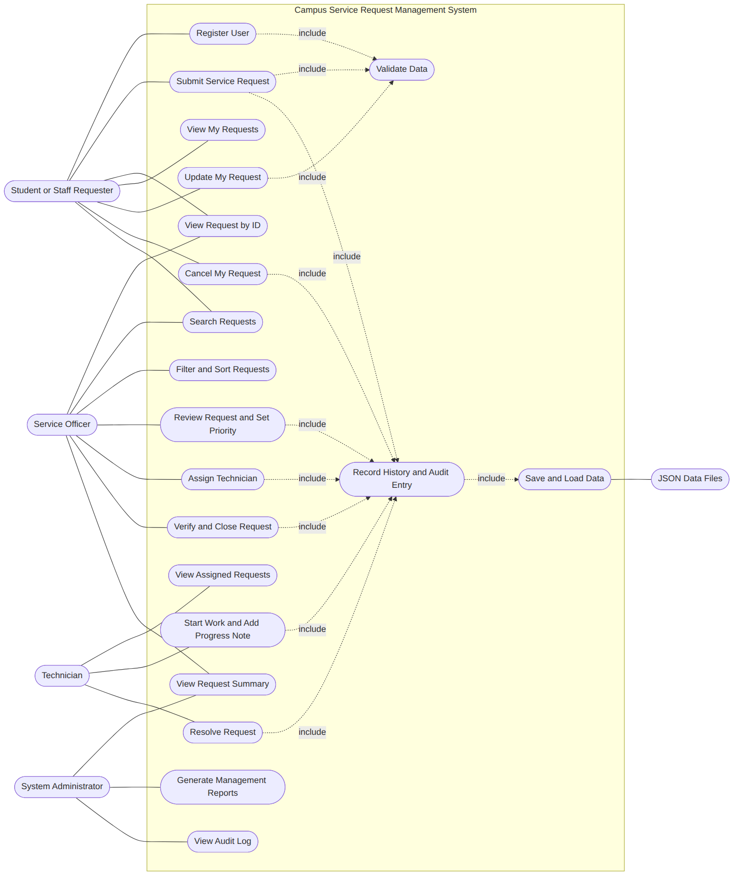
Figure 1: Use Case Diagram
Notes
- Use cases 1 to 7 and 15 make up the Pass system; 8 to 14 are the Credit workflow and search/filter/sort; 16, 17 and the “Save and Load Data” use case are Distinction.
- Every role check is performed by the system when an action is attempted, not by hiding menu options (see the Technical Documentation).

2. Complete Class Diagram
Getters (and controlled setters) for every private field are omitted to keep the diagram readable; - marks a private member, + a public member, and a * after a method marks an abstract-style method (base class throws an error). Types are shown after names.
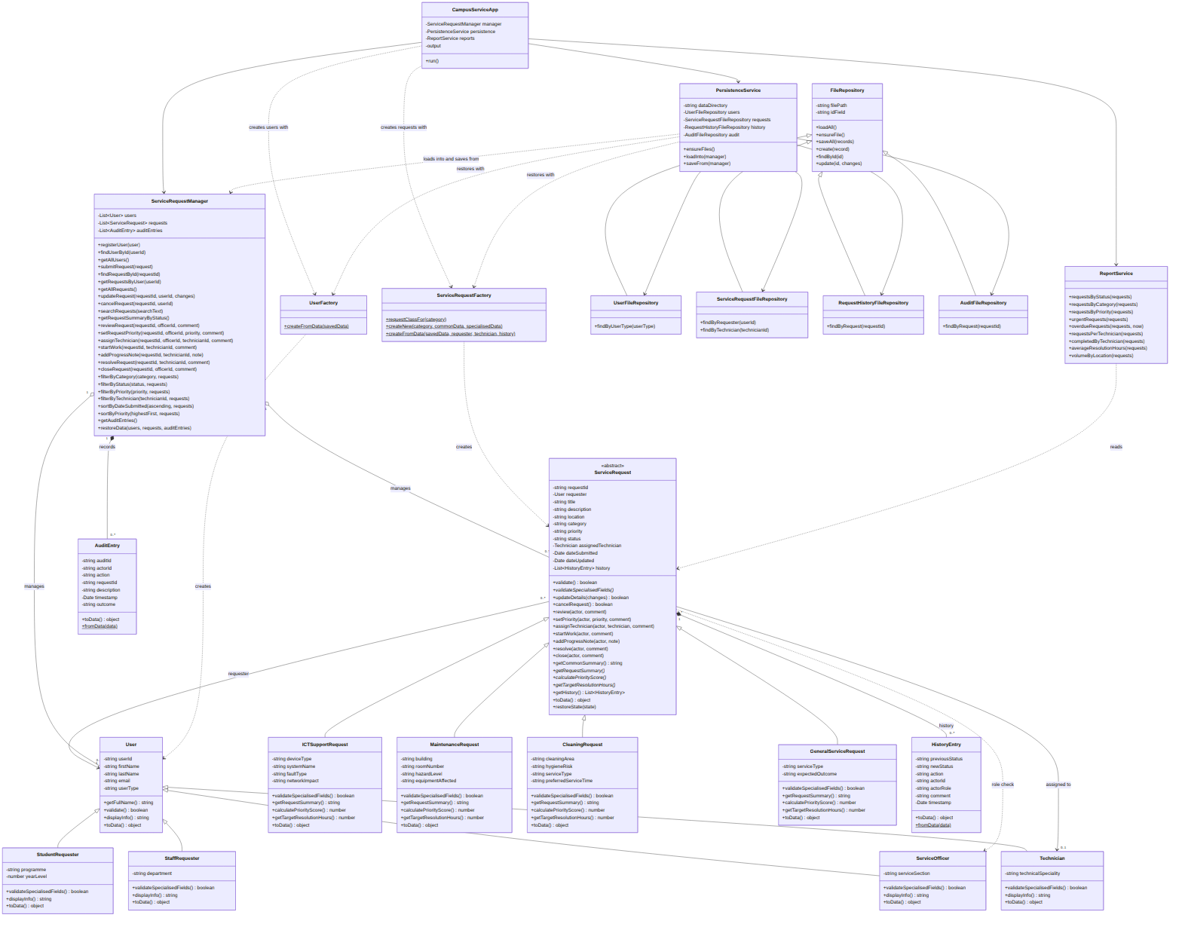
Figure 2: Complete Class Diagram

2.1 Explanation of class relationships
Relationship | Where it appears | Meaning
Inheritance (is-a) | StudentRequester, StaffRequester, ServiceOfficer, Technician extend User; ICTSupportRequest, MaintenanceRequest, CleaningRequest, GeneralServiceRequest extend ServiceRequest; the four repositories extend FileRepository. | Subclasses reuse the base state and behaviour, call the base constructor with super(), and add or override behaviour. ServiceRequest is abstract-style: it defines getRequestSummary(), calculatePriorityScore() and getTargetResolutionHours() but throws an error unless a subclass overrides them.
Composition (owns, lifetime tied) | ServiceRequest owns its HistoryEntry objects; ServiceRequestManager owns its AuditEntry objects. | A history entry has no meaning without its request, and audit entries live only inside the manager’s record.
Aggregation (has, independent lifetime) | ServiceRequestManager holds User and ServiceRequest objects. | The manager collects users and requests in arrays but does not create their identity; they are supplied to it.
Association (knows) | A request refers to its requester (User, exactly one) and optionally to its assigned Technician (0..1). | Composition of objects by reference: a request does not copy the user, it points at the registered one.
Dependency (uses) | CampusServiceApp uses ServiceRequestFactory; factories create domain objects; PersistenceService uses repositories, factories and the manager; ReportService reads requests; ServiceRequest checks roles using ServiceOfficer/Technician. | Short-lived “uses” links: the class does not keep the other as long-term state.

2.2 Separation of responsibilities
Layer | Classes | Rule
Domain | User family, ServiceRequest family, HistoryEntry, AuditEntry | Hold data, enforce validation and workflow rules. No console or file access.
Application logic | ServiceRequestManager, ReportService | Coordinate objects, enforce ownership and roles, produce results. No console or file access.
Persistence | FileRepository family, PersistenceService, factories | The only code that touches fs/promises; turns objects into plain data and back.
User interface | CampusServiceApp | Reads input, calls the manager, prints output. Never reads or writes JSON directly.

3. Status Lifecycle (state diagram)
Supporting diagram for the controlled workflow (Credit). Closed and Cancelled are final.
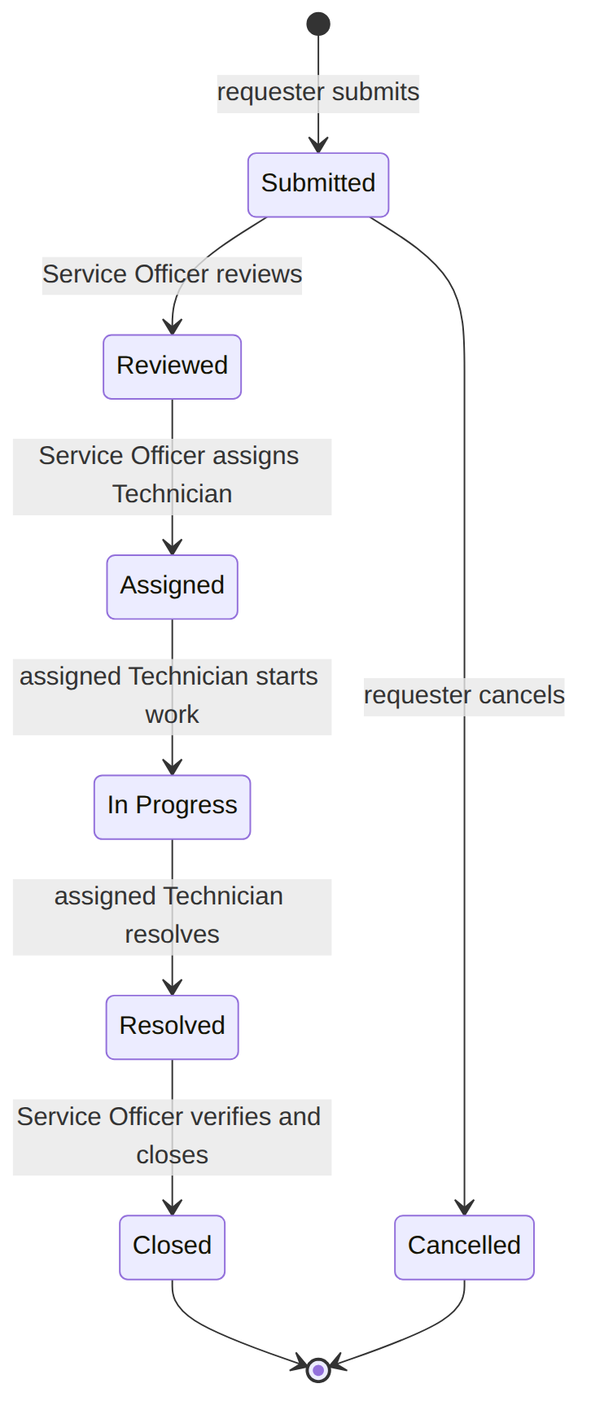
Figure 3: Status Lifecycle (state diagram)

4. Sequence Diagram: Submitting a Request
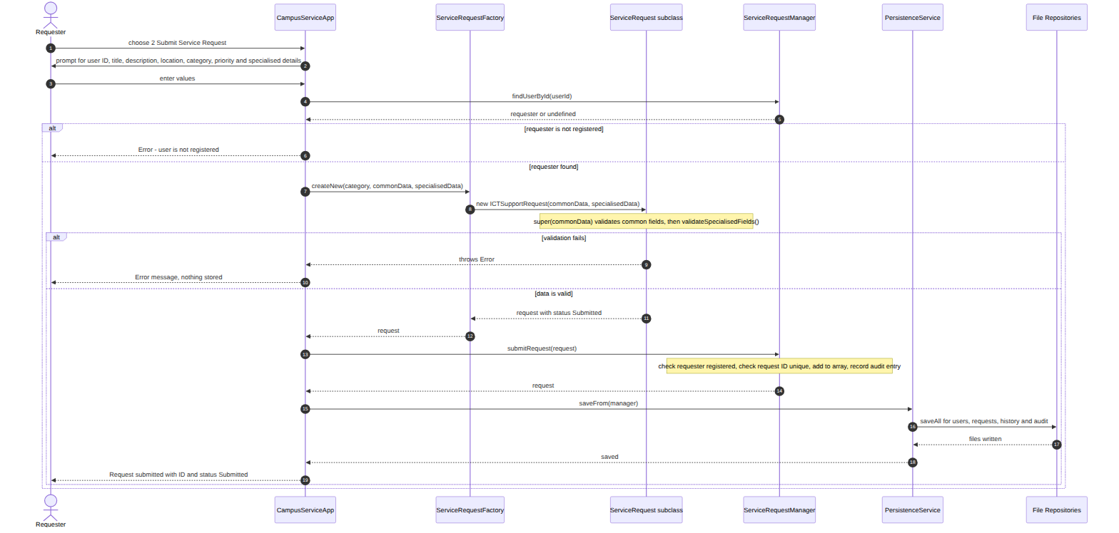
Figure 4: Sequence Diagram — Submitting a Request

5. Sequence Diagram: Assigning a Technician
Precondition: the request has status Reviewed.
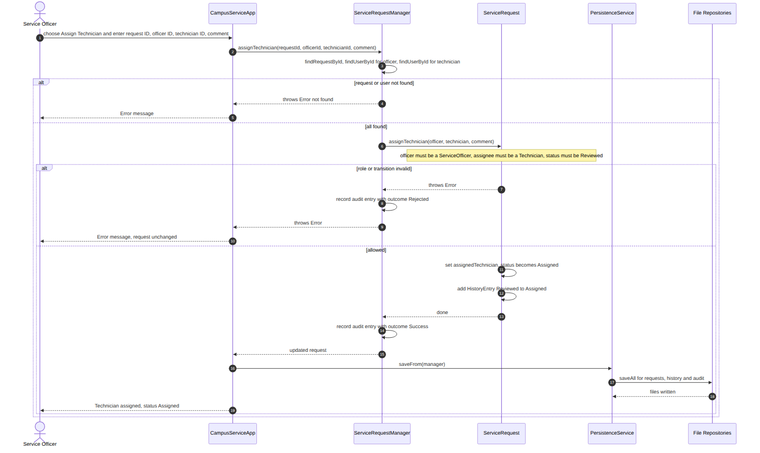
Figure 5: Sequence Diagram — Assigning a Technician

6. Sequence Diagram: Resolving and Closing a Request
Precondition: the request is In Progress. Part A is performed by the assigned Technician, Part B by a Service Officer.
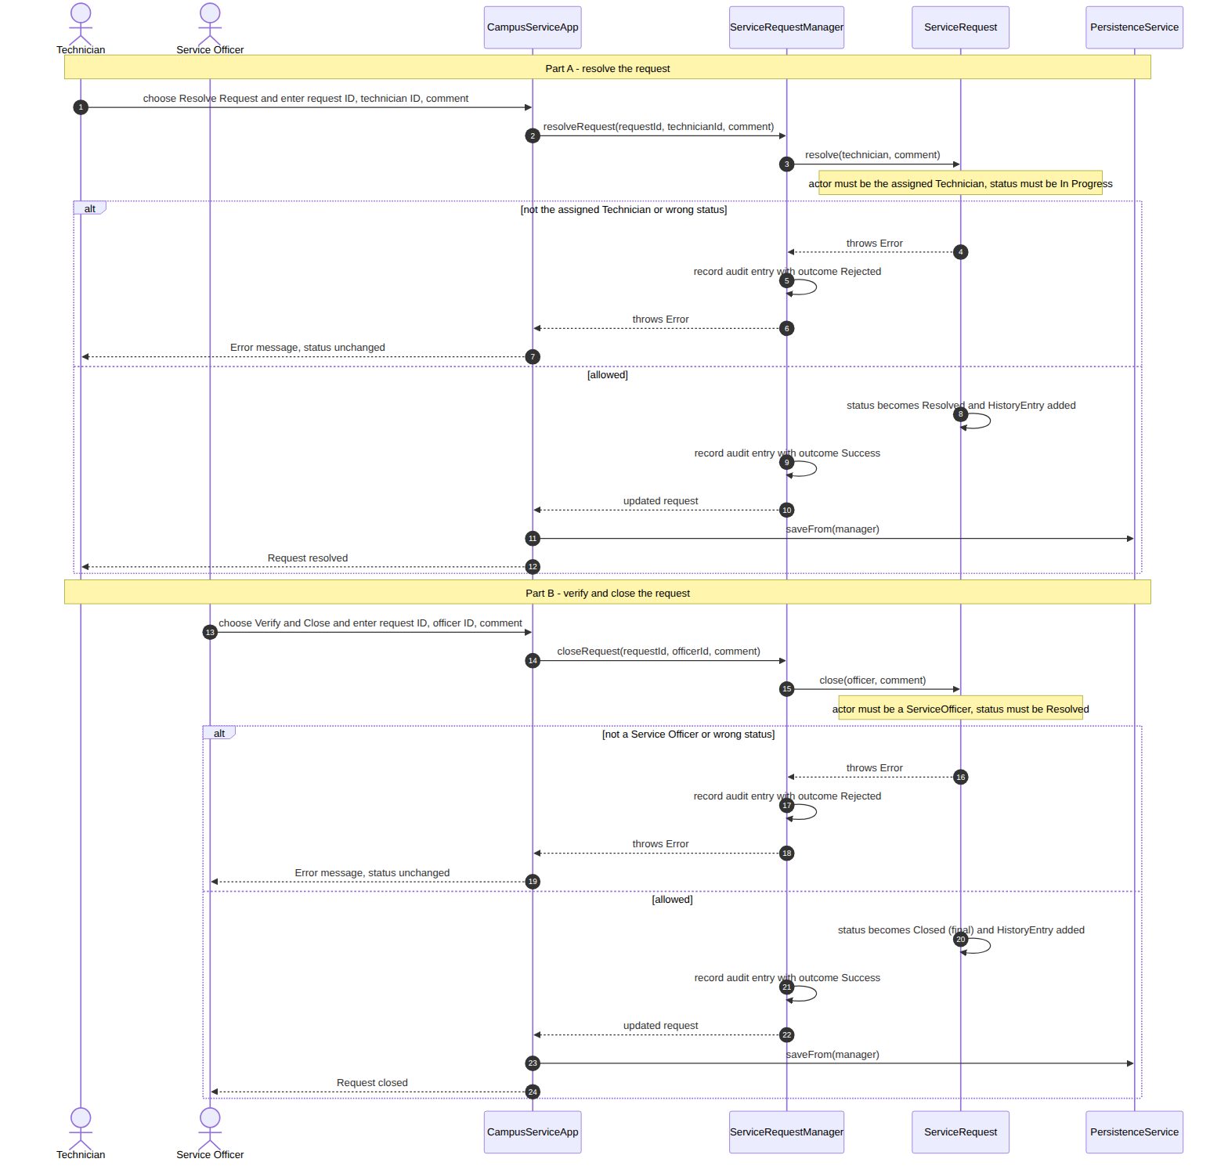
Figure 6: Sequence Diagram — Resolving and Closing a Request

3. Technical Documentation

1. Overview
The system is a Node.js console application (JavaScript classes, no database, no third-party packages). Users register, submit service requests in four categories, and requests move through a controlled workflow handled by Service Officers and Technicians. Data survives restarts because it is saved to four JSON files.
The code is arranged in four layers:
Layer | Classes | Rule
Domain | User and subclasses, ServiceRequest and subclasses, HistoryEntry, AuditEntry | Hold data; enforce validation, roles and workflow rules.
Application logic | ServiceRequestManager, ReportService | Coordinate objects; enforce ownership; write audit entries. No console or file access.
Persistence | FileRepository and 4 subclasses, PersistenceService, UserFactory, ServiceRequestFactory | The only code that touches fs/promises; converts objects to plain data and back.
User interface | CampusServiceApp | Reads input, calls the manager, prints output.

2. Project Folder Structure
AT3_CampusServiceRequestSystem/
├── data/
│ ├── auditLog.json
│ ├── requestHistory.json
│ ├── serviceRequests.json
│ └── users.json
│ ├── evidence/
│ │ ├── check_design_output.txt
│ │ ├── console_session_A_first_start_register_submit.txt
│ │ ├── console_session_B_restart_and_full_workflow.txt
│ │ ├── console_session_C_errors_and_roles.txt
│ │ ├── console_session_D_administrator_reports.txt
│ │ └── npm_test_output.txt
│ ├── repositories/
│ │ ├── AuditFileRepository.js
│ │ ├── FileRepository.js
│ │ ├── RequestHistoryFileRepository.js
│ │ ├── ServiceRequestFileRepository.js
│ │ └── UserFileRepository.js
│ ├── AuditEntry.js
│ ├── CampusServiceApp.js
│ ├── CleaningRequest.js
│ ├── GeneralServiceRequest.js
│ ├── HistoryEntry.js
│ ├── ICTSupportRequest.js
│ ├── MaintenanceRequest.js
│ ├── PersistenceService.js
│ ├── ReportService.js
│ ├── ServiceOfficer.js
│ ├── ServiceRequest.js
│ ├── ServiceRequestFactory.js
│ ├── ServiceRequestManager.js
│ ├── StaffRequester.js
│ ├── StudentRequester.js
│ ├── Technician.js
│ ├── User.js
│ ├── UserFactory.js
│ └── validation.js
│ ├── User Manual/
│ │ ├── user manual.md
│
- AT3_CampusServiceRequestSystem/: holds the application
- repositories/: holds the file-access classes.
- data/: holds the four JSON files (simulated sample data, created by npm run seed).

3. Responsibility of Each Class
Class | Responsibility
User | Base class: user ID, name, email and type; validation; getFullName(), displayInfo(), toData().
StudentRequester, StaffRequester | People who submit requests; add programme/year level or department.
ServiceOfficer | Reviews requests, sets priority, assigns Technicians, closes resolved requests; adds service section.
Technician | Carries out assigned work; adds technical speciality.
ServiceRequest | Abstract-style base: common fields and validation, the status workflow, role checks, history, updateDetails(), cancelRequest(), toData(), restoreState(). Declares the methods subclasses must supply.
ICTSupportRequest, MaintenanceRequest, CleaningRequest, GeneralServiceRequest | Add type-specific fields and validation; override summary, priority score and target resolution time.
HistoryEntry | Immutable record of one action on one request (previous/new status, action, actor, comment, time).
AuditEntry | Immutable record of one system action with its outcome (Success or Rejected).
ServiceRequestManager | Holds users, requests and audit entries in arrays; registers, submits, searches, filters, sorts; runs each workflow action through #perform() so it is audited.
ServiceRequestFactory | Chooses which request class to build: from a category (new request) or from saved data (restore).
UserFactory | Builds the correct User subclass from a data object (console input or saved JSON).
FileRepository (+ UserFileRepository, ServiceRequestFileRepository, RequestHistoryFileRepository, AuditFileRepository) | Read and write one JSON file of plain records; create missing files; refuse incomplete or duplicate records; report file errors clearly.
PersistenceService | Loads the four files into the manager (using the factories) and saves the manager back to the four files.
ReportService | Nine management reports built with filter, map, reduce and sort.
CampusServiceApp | Console menus. Never touches files directly.

4. Where Encapsulation Is Used
- Private fields. Every domain class keeps its state in JavaScript #private fields, so other code cannot read or change them directly. Only getters and validated methods are public.
#userId;
#firstName;
#lastName;
#email;
#userType;
- Controlled setters. A setter checks the new value before storing it, so an object can never be put into an invalid state.
set email(value) {
const v = clean(value);
if (!EMAIL_PATTERN.test(v)) throw new Error('A valid email address is required.');
this.#email = v;
}
- Controlled methods instead of setters. A request’s status and priority have no public setter. They change only through workflow methods (review(), assignTechnician(), and so on), which check roles and the transition table first.
- Private methods. ServiceRequest hides its rule-enforcing helpers (#transition(), #record(), #requireAssignedTechnician(), #findProblems()), and the manager hides #perform(), #audit() and #getOwnedRequest().
- Protective copies. Getters return copies where a caller could otherwise damage internal state: getHistory() returns a copy of the history array, getAllRequests() returns a copy of the requests array, and date getters return new Date objects.
- Immutable records. HistoryEntry and AuditEntry have private fields and getters only, so a history or audit record cannot be edited after it is created.

5. Inheritance and Constructor Chaining
Three families use inheritance:
Base class | Subclasses
User | StudentRequester, StaffRequester, ServiceOfficer, Technician
ServiceRequest | ICTSupportRequest, MaintenanceRequest, CleaningRequest, GeneralServiceRequest
FileRepository | UserFileRepository, ServiceRequestFileRepository, RequestHistoryFileRepository, AuditFileRepository
- Constructor chaining (users). Each subclass constructor calls the base constructor with super() first, so the shared fields are validated, then it sets and validates its own.
constructor(userId, firstName, lastName, email, programme, yearLevel) {
super(userId, firstName, lastName, email, 'Student'); // constructor chaining
this.#programme = clean(programme);
this.#yearLevel = Number(yearLevel);
this.validateSpecialisedFields();
}
- Constructor chaining (requests). The common request data travels in one object, so every request subclass simply passes it up with super(commonRequestData), then handles its own data.
constructor(commonRequestData, specialisedData = {}) {
super({ ...commonRequestData, category: clean(commonRequestData?.category) || ICTSupportRequest.CATEGORY }); // constructor chaining
this.#deviceType = clean(specialisedData.deviceType);
this.#systemName = clean(specialisedData.systemName);
this.#faultType = clean(specialisedData.faultType);
this.#networkImpact = clean(specialisedData.networkImpact) || 'None';
this.validateSpecialisedFields();
}
Note: The base constructor cannot call a method that reads the subclass’s private fields, because those fields do not exist until super() returns. For that reason the base class validates only the common fields, and each subclass validates its own fields at the end of its constructor with validateSpecialisedFields().

6. Where Overriding and Polymorphism Are Used

6.1 Abstract-style base class
ServiceRequest declares four methods that only make sense for a specific request type. Its own versions throw a clear error, so a subclass that forgets to override one fails loudly instead of returning wrong results.
#mustOverride(methodName) {
return new Error(
`ServiceRequest is abstract: ${this.constructor.name} must override ${methodName}().`
);
}
validateSpecialisedFields() { throw this.#mustOverride('validateSpecialisedFields'); }
getRequestSummary() { throw this.#mustOverride('getRequestSummary'); }
calculatePriorityScore() { throw this.#mustOverride('calculatePriorityScore'); }
getTargetResolutionHours() { throw this.#mustOverride('getTargetResolutionHours'); }
The manager also refuses an untyped request: submitRequest() calls request.validateSpecialisedFields(), which throws for a bare ServiceRequest.

6.2 Overriding
Each request subclass overrides all four methods. The same method name produces different behaviour in each class:
calculatePriorityScore() {
return ServiceRequest.PRIORITY_WEIGHTS[this.priority] + ICTSupportRequest.#IMPACT_SCORE[this.#networkImpact];
}
getTargetResolutionHours() {
return Math.min(
ICTSupportRequest.#BASE_HOURS[this.priority],
ICTSupportRequest.#IMPACT_HOURS_CAP[this.#networkImpact]
);
}
Compare the Maintenance version, which scores by hazard level instead of network impact:
calculatePriorityScore() {
return ServiceRequest.PRIORITY_WEIGHTS[this.priority] + MaintenanceRequest.#HAZARD_SCORE[this.#hazardLevel];
}
getTargetResolutionHours() {
return Math.min(
MaintenanceRequest.#BASE_HOURS[this.priority],
MaintenanceRequest.#HAZARD_HOURS_CAP[this.#hazardLevel]
);
}
Type-specific rules used by the overrides
Class | Priority score = priority weight + | Target hours = min(base hours for priority, cap)
ICTSupportRequest | network impact: None 0, Single User 5, Department 15, Campus-wide 25 | base: Urgent 4, High 8, Normal 24, Low 72. Cap: Department 8, Campus-wide 4
MaintenanceRequest | hazard: None 0, Low 5, Medium 15, High 30 | base: Urgent 8, High 24, Normal 72, Low 120. Cap: Medium 24, High 8
CleaningRequest | hygiene risk: Low 0, Medium 10, High 20 | base: Urgent 2, High 6, Normal 12, Low 24. Cap: High hygiene risk 4
GeneralServiceRequest | nothing extra | base: Urgent 8, High 24, Normal 48, Low 96
Priority weights (in ServiceRequest.PRIORITY_WEIGHTS): Low 10, Normal 20, High 30, Urgent 40. Other overrides: displayInfo() and toData() in the user subclasses, toData() in the request subclasses, and validateSpecialisedFields() in every subclass.

6.3 Polymorphism
Requests of all four classes live in the same array. Code calls the same methods on each one without checking its type; each object answers in its own way. This is the loop behind the Administrator menu’s polymorphism view:
for (const request of all) {
// The SAME calls work on every request type; each class answers in its own way.
this.#log(`${request.requestId.padEnd(8)} ${request.constructor.name.padEnd(22)} ${String(request.calculatePriorityScore()).padEnd(6)} ${request.getTargetResolutionHours()} hours`);
}
Polymorphism also lets the manager, reports and persistence treat every request identically: getRequestsByUser(), ReportService.overdueRequests() (which calls getTargetResolutionHours() on each request) and PersistenceService.saveFrom() (which calls toData() on each request) never mention a specific subclass.

7. How the Request Workflow Is Controlled
The whole workflow is one lookup table. A status may only change to one of the statuses listed beside it:
static TRANSITIONS = Object.freeze({
Submitted: Object.freeze(['Reviewed', 'Cancelled']),
Reviewed: Object.freeze(['Assigned']),
Assigned: Object.freeze(['In Progress']),
'In Progress': Object.freeze(['Resolved']),
Resolved: Object.freeze(['Closed']),
Closed: Object.freeze([]),
Cancelled: Object.freeze([])
});
Every status change goes through one private method, so no other code can change a status:
#transition(newStatus, action, actor, comment, beforeCommit = () => {}) {
const allowed = ServiceRequest.TRANSITIONS[this.#status];
if (!allowed.includes(newStatus)) {
const next = allowed.length > 0 ? allowed.join(' or ') : 'none (final status)';
throw new Error(
`Invalid status transition: a request that is ${this.#status} cannot become ${newStatus}. Allowed next status: ${next}.`
);
}
beforeCommit();
const previous = this.#status;
this.#status = newStatus;
this.#record(previous, newStatus, action, actor, comment);
}
Every workflow method performs its checks in the same order:
- Role. Is the actor allowed? (Access denied: only a Service Officer can ...)
- Transition. Is the move allowed from the current status? (Invalid status transition ...)
- Record. Change the status and add a HistoryEntry. The manager adds an AuditEntry.
static #requireOfficer(actor, what) {
if (!(actor instanceof ServiceOfficer)) {
throw new Error(`Access denied: only a Service Officer can ${what}.`);
}
}
Action | Method | Who | From status | To status
Submit | constructor | Requester | (new) | Submitted
Review | review() | Service Officer | Submitted | Reviewed
Set priority | setPriority() | Service Officer | Reviewed | (unchanged)
Assign | assignTechnician() | Service Officer | Reviewed | Assigned
Start | startWork() | Assigned Technician | Assigned | In Progress
Progress note | addProgressNote() | Assigned Technician | In Progress | (unchanged)
Resolve | resolve() | Assigned Technician | In Progress | Resolved
Close | close() | Service Officer | Resolved | Closed
Cancel | cancelRequest() | Requester (owner) | Submitted | Cancelled
Update details | updateDetails() | Requester (owner) | Submitted | (unchanged)
Closed and Cancelled have no allowed next status, so they are final. A rejected action changes nothing and adds no history entry (but is recorded in the audit log as Rejected).
Audit trail. Every manager method that changes data runs through #perform(), which records Success or Rejected (with the reason):
#perform(actorId, action, requestId, description, operation) {
try {
const result = operation();
this.#audit(actorId, action, requestId, description, 'Success');
return result;
} catch (error) {
this.#audit(actorId, action, requestId, `${description} Reason: ${error.message}`, 'Rejected');
throw error;
}
}

8. How Validation and Errors Are Handled
Principle: invalid data is rejected at the earliest point, with a clear message, by throwing an Error. Objects are validated when they are constructed, so an invalid object never exists. CampusServiceApp catches every error, prints Error: <message>, and returns to the menu, so the program never crashes on bad input.
static #findProblems(fields) {
const problems = [];
if (!fields.title) problems.push('Request title is required.');
if (!fields.description) problems.push('Request description is required.');
if (!fields.location) problems.push('Campus location is required.');
if (!ServiceRequest.CATEGORIES.includes(fields.category)) {
problems.push(`Unsupported category "${fields.category}". Allowed: ${ServiceRequest.CATEGORIES.join(', ')}.`);
}
if (!ServiceRequest.PRIORITIES.includes(fields.priority)) {
problems.push(`Unsupported priority "${fields.priority}". Allowed: ${ServiceRequest.PRIORITIES.join(', ')}.`);
}
return problems;
}
Problems are collected into one message so the user sees everything wrong at once.
Rule | Enforced in | Example message
Missing user ID, names | User constructor / setters | User ID is required.
Invalid email | User | A valid email address is required.
Duplicate user ID | ServiceRequestManager.registerUser | Duplicate user ID: DWU2026001 is already registered.
Wrong specialised user data | subclass validateSpecialisedFields | Programme is required.
Missing title / description / location | ServiceRequest | Request title is required.
Unsupported category or priority | ServiceRequest, ServiceRequestFactory | Unsupported category "Furniture". Allowed: ICT Support, ...
Wrong specialised request data | subclass validateSpecialisedFields | Network impact must be one of: None, Single User, ...
Duplicate request ID | manager submitRequest | Duplicate request ID: REQ001 already exists.
Requester not registered, or not student/staff | manager submitRequest | Only students and staff can submit service requests.
Changing another user’s request | manager #getOwnedRequest | Access denied: you can only change your own requests.
Update/cancel when not Submitted | ServiceRequest | Only Submitted requests can be cancelled (current status: Reviewed).
Cancel twice | ServiceRequest.cancelRequest | This request is already Cancelled.
Wrong role for a workflow step | ServiceRequest | Access denied: only a Service Officer can assign a Technician.
Not the assigned Technician | ServiceRequest | Access denied: only the assigned Technician can start the work. This request is assigned to TECH001.
Invalid status change | ServiceRequest.#transition | Invalid status transition: a request that is Cancelled cannot become Assigned. Allowed next status: none (final status).
Category change | ServiceRequest.updateDetails | The category cannot be changed. ...
Update with no changes | ServiceRequest.updateDetails | No changes were supplied.
Missing file / empty file | FileRepository.loadAll | (not an error) empty array returned
Corrupt JSON | FileRepository.loadAll | Cannot read <path>: the file does not contain valid JSON.
Cannot write a file | FileRepository.saveAll | Cannot write <path>: ...
Incomplete / duplicate record | FileRepository.saveAll | Cannot save an incomplete record: "requestId" is missing.
Invalid saved record | PersistenceService.loadInto | Saved request R1 is invalid: requester GHOST is not in users.json
All-or-nothing behaviour. updateDetails() checks the whole change before applying any of it; restoreData() validates every saved record before replacing anything; saveAll() writes a temporary file and then swaps it in, so a failed save cannot leave a half-written file.
Startup safety. If a data file is corrupt, the application prints the error and stops without overwriting the file, so the user’s data is never destroyed by a failed load.

9. How JSON Data Is Stored and Restored

9.1 Files
data/ holds four files, each a JSON array of plain records (data only, never code):
File | One record per | Key
users.json | user | userId
serviceRequests.json | request | requestId
requestHistory.json | history entry | historyId (REQ001-1, REQ001-2, …)
auditLog.json | audit entry | auditId (AUD0001, …)
- Example request record (requestType names the class to rebuild; specialised fields sit in details):
{
"requestId": "REQ001",
"requestType": "ICTSupportRequest",
"requesterId": "DWU2026001",
"title": "Unable to access campus Wi-Fi",
"description": "Cannot connect to Wi-Fi from the library.",
"location": "Library Level 2",
"category": "ICT Support",
"priority": "High",
"status": "Assigned",
"assignedTechnicianId": "TECH001",
"dateSubmitted": "2026-09-21T09:30:42.612Z",
"dateUpdated": "2026-09-21T09:30:42.613Z",
"details": {
"deviceType": "Laptop",
"systemName": "Campus Wi-Fi",
"faultType": "Connection failure",
"networkImpact": "Department"
}
}
- Example history record:
{
"historyId": "REQ001-1",
"requestId": "REQ001",
"previousStatus": "None",
"newStatus": "Submitted",
"action": "Submit Request",
"actorId": "DWU2026001",
"actorRole": "Student",
"comment": "Request submitted.",
"timestamp": "2026-09-21T09:30:42.613Z"
}
- Example audit record:
{
"auditId": "AUD0001",
"actorId": "DWU2026001",
"action": "Register User",
"requestId": null,
"description": "Register DWU2026001.",
"timestamp": "2026-09-21T09:30:42.612Z",
"outcome": "Success"
}

9.2 Saving
CampusServiceApp calls PersistenceService.saveFrom(manager) after every menu action that can change data (including rejected attempts, which are audited). saveFrom():
- validates every user and request object (invalid objects are never saved);
- converts objects to plain data with toData();
- writes the four files through the repositories.

9.3 Loading and restoring objects
JSON holds plain data, not live objects, so loading rebuilds the correct classes. PersistenceService.loadInto(manager):
- creates any missing file as an empty array;
- rebuilds users with UserFactory (so a "userType": "Technician" record becomes a real Technician);
- groups history rows by request ID;
- for each request, finds its requester and Technician objects and calls ServiceRequestFactory.createFromData(...);
- rebuilds audit entries;
- gives everything to manager.restoreData(), which validates it all before replacing anything.
The factory uses requestType to choose the class, rebuilds it through the normal constructor (so validation still runs), then restores the saved state:
request.restoreState({
status: savedData.status,
assignedTechnician: technician,
dateSubmitted: savedData.dateSubmitted,
dateUpdated: savedData.dateUpdated,
history: history.map((row) => HistoryEntry.fromData(row))
});
Because the real subclasses are rebuilt, restored objects keep their behaviour: role checks (instanceof ServiceOfficer) still work, and overridden methods still give type-specific results. Tests D-14, D-15 and D-16 prove this.

10. How Tests Are Organised
Tests use the built-in Node.js test runner (node:test) and node:assert/strict. Run them with npm test.
File | Level | Tests | Covers
test/pass.test.js | Pass | 20 (P-01 to P-20) | Registration, validation, duplicates, submit, view, update, cancel, search, summary.
test/credit.test.js | Credit | 19 (C-01 to C-19) | Inheritance, constructor chaining, specialised fields, roles, transitions, history, overriding, search/filter/sort.
test/distinction.test.js | Distinction | 28 (D-01 to D-28) | Abstraction, polymorphism, factories, repositories, missing/corrupt/unwritable files, save and restore, audit, reports, console app runs.
- Test IDs appear in the test names and in 05_Test_Report.md.
- test-support/builders.js provides helpers (makeWorld(), makeRequest(), makeTempDir()), kept outside test/ so they are not run as tests.
- Tests never touch data/. Every file test uses a temporary folder created by makeTempDir() and deleted afterwards. Test D-28 copies the sample data to a temporary folder before loading it. Test D-27 checks that only FileRepository uses the file system.
- The console app is tested by running the real CampusServiceApp with scripted input and captured output (D-24 to D-26), including a restart to prove data survives.
- npm run check-design compares the class and sequence diagrams with the code.

11. Known Limitations and Future Improvements
Limitations
- No authentication: the user ID typed at the console is trusted, and JSON files are plain text.
- Administrator-only reports are protected by a check in CampusServiceApp, not in the domain; the workflow roles (Officer, Technician) are enforced in the domain classes.
- Every save rewrites all four files, which suits demonstration data but not very large data sets.
- One person at a time: there is no protection against two programs writing the same files.
- The category of a request cannot be changed (the category decides the request class); the requester must cancel and resubmit. Specialised fields cannot be edited after submission.
- The “update request” prompts ask for all fields before the ownership check runs, so another user’s update is rejected only after the questions are answered.
- Email validation checks format only. Times and dates use the computer’s clock and locale.
- Console interface only; no notifications.
Future improvements
- Passwords or login, with role-based menus that show only permitted actions.
- A database or per-record files for larger data sets, keeping the repository classes as the only change.
- Editing specialised fields; letting a Service Officer cancel or reassign a request.
- Notifications when a request changes status; a web or graphical interface on top of the same classes.
- Configurable target resolution times and priority scores.
- Exporting reports to CSV.

4. Test Report

1. Test Environment
Item | Value
Node.js | v22.22.2
Test runner | Built-in Node.js test runner (node --test), assertions from node:assert/strict
Commands | npm test, npm run check-design, and console sessions with node src/CampusServiceApp.js
Test data | Temporary folders for file tests; simulated sample data in data/ for console sessions

2. Summary
Level | Test file | Passed | Total
Pass | test/pass.test.js | 20 | 20
Credit | test/credit.test.js | 19 | 19
Distinction | test/distinction.test.js | 28 | 28
All automated tests |  | 67 | 67
Manual console tests | Sessions A to D | 35 | 35
Design check | npm run check-design | 225 checks passed, 0 problem(s).
Failed automated tests: none.

3. Automated Tests

3.1 Pass tests (test/pass.test.js)
Test ID | Feature tested | Test input | Expected result | Actual result | Result | Evidence
P-01 | Valid user registration | Register U1 (Student, Mary Kila) and U2 (Staff, John Taru) | Both stored; U1 found as “Mary Kila”; U2 has type Staff | As expected: all assertions passed | Pass | npm test: ✔ P-01
P-02 | Duplicate user ID is rejected | Register a second user with the ID U1 | Rejected: Duplicate user ID | As expected: all assertions passed | Pass | npm test: ✔ P-02
P-03 | Missing user ID is rejected | new User(’‘, ’Mary’, ‘Kila’, email, ‘Student’) | Rejected: User ID is required | As expected: all assertions passed | Pass | npm test: ✔ P-03
P-04 | Missing first or last name is rejected | Empty first name; blank last name | Rejected: First name is required / Last name is required | As expected: all assertions passed | Pass | npm test: ✔ P-04
P-05 | Invalid email address is rejected | Emails “abc”, “mary@dwu”, ““,”mary dwu@x.com” | Each rejected: A valid email address is required | As expected: all assertions passed | Pass | npm test: ✔ P-05
P-06 | Valid request submission is stored with Submitted status | Submit a valid ICT request R1 for U1 | Stored with status Submitted; found by ID; 1 request in total | As expected: all assertions passed | Pass | npm test: ✔ P-06
P-07 | Duplicate request ID is rejected | Submit a second request with ID R1 | Rejected: Duplicate request ID | As expected: all assertions passed | Pass | npm test: ✔ P-07
P-08 | Missing request title or description is rejected | Empty title; blank description | Rejected: title is required / description is required | As expected: all assertions passed | Pass | npm test: ✔ P-08

3.2 Credit tests (test/credit.test.js)
Test ID | Feature tested | Test input | Expected result | Actual result | Result | Evidence
C-01 | User subclasses call super() and inherit User behaviour | Create a StudentRequester, StaffRequester, ServiceOfficer and Technician | Each is a User; super() sets the user type; inherited getFullName() works; displayInfo() shows the programme | As expected: all assertions passed | Pass | npm test: ✔ C-01
C-02 | Specialised user fields are validated | Blank programme; year level 9 and “two”; blank department, section, speciality; blank user ID with a valid speciality | Each rejected with a specific message; base User checks still apply | As expected: all assertions passed | Pass | npm test: ✔ C-02
C-03 | Request subclasses call super() and start as Submitted | Create one request of each category through the factory | Correct subclass, instance of ServiceRequest, status Submitted, category set, history holds 1 entry | As expected: all assertions passed | Pass | npm test: ✔ C-03
C-04 | Specialised request fields are validated | Invalid specialised values for each request type; ICT class with a Cleaning category; empty title | Each rejected with a field-specific message | As expected: all assertions passed | Pass | npm test: ✔ C-04
C-05 | Only a Service Officer can review a request and set its priority | Student and Technician try to review; officer reviews; student sets priority; officer sets Urgent, then “Critical” | Non-officers rejected (Access denied); officer succeeds; invalid priority rejected | As expected: all assertions passed | Pass | npm test: ✔ C-05
C-06 | Only a Service Officer can assign a Technician, and only to a Technician | Student and Technician try to assign; officer assigns a student, an unknown ID, then T1 | First four rejected; T1 assigned and status becomes Assigned | As expected: all assertions passed | Pass | npm test: ✔ C-06

3.3 Distinction tests (test/distinction.test.js)
Test ID | Feature tested | Test input | Expected result | Actual result | Result | Evidence
D-01 | The abstract-style base class throws clear errors for methods subclasses must supply | Call the four abstract-style methods on a base request; a subclass missing one override; submit an untyped request | Each throws “ServiceRequest is abstract: X must override m()”; manager refuses the untyped request | As expected: all assertions passed | Pass | npm test: ✔ D-01
D-02 | Polymorphism: one collection, the same method calls, type-specific results | One array holding the four types; the same three method calls on each | Different classes; scores [45, 45, 50, 30]; hours [8, 24, 4, 24]; each summary names its own type | As expected: all assertions passed | Pass | npm test: ✔ D-02
D-03 | UserFactory rebuilds the correct User subclass from saved data | Five user types to JSON data and back through UserFactory; unknown type; missing field | Same class and data each time; unknown type and missing field rejected | As expected: all assertions passed | Pass | npm test: ✔ D-03
D-04 | ServiceRequestFactory rebuilds every request type with its state and history | Five requests in different states: convert to JSON and rebuild through the factory | Same class, same data and same history for each | As expected: all assertions passed | Pass | npm test: ✔ D-04
D-05 | ServiceRequestFactory rejects unknown types, mismatched requesters and impossible states | Unknown request type; wrong requester; bad status; Assigned without Technician; bad date; bad details; unsupported category; Technician on a Submitted request | Each rejected with a clear message | As expected: all assertions passed | Pass | npm test: ✔ D-05

4. Manual Console Tests
These tests drive the real program through its menus. The Actual result is the exact line the program printed, copied from the captured session named in the Evidence column.
Test ID | Feature tested | Test input | Expected result | Actual result | Result | Evidence
M-01 | Start-up with an empty data folder | node src/CampusServiceApp.js | Loads zero records and shows the main menu | Loaded 0 user(s), 0 request(s) and 0 audit entries from <project folder>/data | Pass | Session A: evidence/console_session_A_first_start_register_submit.txt
M-02 | Register a student (option 1) | DWU2026001, Mary Kila, email, Student, programme, year 2 | User registered with programme and year | User registered: ID: DWU2026001 | Name: Mary Kila | Email: mary.kila@example.com | Type: Student | Programme: Bachelor of Information Systems | Year: 2 | Pass | Session A: evidence/console_session_A_first_start_register_submit.txt
M-03 | Register a Service Officer (option 1) | OFFICER001, type 3, section “Campus Services” | Registered as a Service Officer with section | User registered: ID: OFFICER001 | Name: Grace Wamil | Email: grace.wamil@example.com | Type: Service Officer | Section: Campus Services | Pass | Session A: evidence/console_session_A_first_start_register_submit.txt
M-04 | Register a Technician (option 1) | TECH001, type 4, speciality “Networks and ICT” | Registered as a Technician with speciality | User registered: ID: TECH001 | Name: Ravu Sopi | Email: ravu.sopi@example.com | Type: Technician | Speciality: Networks and ICT | Pass | Session A: evidence/console_session_A_first_start_register_submit.txt
M-05 | Register an Administrator (option 1) | ADMIN001, type 5 | Registered as an Administrator | User registered: ID: ADMIN001 | Name: Samuel Gari | Email: samuel.gari@example.com | Type: Administrator | Pass | Session A: evidence/console_session_A_first_start_register_submit.txt
M-06 | Submit an ICT Support request (option 2) | DWU2026001, title, description, location, category 1, priority 3, ICT details, impact 3 | Request REQ001 created with status Submitted | Request submitted with ID REQ001 (status: Submitted). | Pass | Session A: evidence/console_session_A_first_start_register_submit.txt
M-07 | View request shows type-specific details (option 3) | REQ001 | Shows ICT fields, priority score 45 and target 8 hours | Priority Score : 45 | Pass | Session A: evidence/console_session_A_first_start_register_submit.txt
M-08 | Restart shows saved data (persistence) | Start the program a second time | All 4 users, the request and audit entries are loaded | Loaded 4 user(s), 1 request(s) and 5 audit entries from <project folder>/data | Pass | Session B: evidence/console_session_B_restart_and_full_workflow.txt
M-09 | Officer reviews a request (menu 11) | OFFICER001, Review, REQ001 | Status becomes Reviewed | Request REQ001 is now Reviewed. | Pass | Session B: evidence/console_session_B_restart_and_full_workflow.txt
M-10 | Officer sets priority (menu 11) | Set priority, REQ001, Urgent | Priority becomes Urgent | Request REQ001 priority is now Urgent. | Pass | Session B: evidence/console_session_B_restart_and_full_workflow.txt
M-11 | Officer assigns a Technician (menu 11) | Assign, REQ001, TECH001 | Status Assigned, Technician named | Request REQ001 is now Assigned, assigned to Ravu Sopi. | Pass | Session B: evidence/console_session_B_restart_and_full_workflow.txt
M-12 | Technician starts work (menu 12) | TECH001, Start work, REQ001 | Status In Progress | Request REQ001 is now In Progress. | Pass | Session B: evidence/console_session_B_restart_and_full_workflow.txt
M-13 | Technician adds a progress note (menu 12) | Add note, REQ001 | Progress note recorded | Progress note recorded. | Pass | Session B: evidence/console_session_B_restart_and_full_workflow.txt
M-14 | Technician resolves (menu 12) | Resolve, REQ001 | Status Resolved | Request REQ001 is now Resolved. | Pass | Session B: evidence/console_session_B_restart_and_full_workflow.txt
M-15 | Officer verifies and closes (menu 11) | Close, REQ001 | Status Closed | Request REQ001 is now Closed. | Pass | Session B: evidence/console_session_B_restart_and_full_workflow.txt
M-16 | History records the complete workflow (option 3) | View REQ001 after closing | History shows Close Request: Resolved -> Closed by OFFICER001 (Service Officer) | [9/21/2026, 7:36:45 PM] Close Request: Resolved -> Closed by OFFICER001 (Service Officer) - Confirmed working with the requester | Pass | Session B: evidence/console_session_B_restart_and_full_workflow.txt
M-17 | Search by text (option 8) | Search “wifi” | REQ001 found | Request ID : REQ001 | Pass | Session B: evidence/console_session_B_restart_and_full_workflow.txt
M-18 | Duplicate user ID rejected | Register DWU2026001 again | Clear error, menu continues | Error: Duplicate user ID: DWU2026001 is already registered. | Pass | Session C: evidence/console_session_C_errors_and_roles.txt
M-19 | Invalid email rejected | Email “peter-at-example” | Clear error | Error: A valid email address is required. | Pass | Session C: evidence/console_session_C_errors_and_roles.txt
M-20 | Unregistered user cannot submit | User ID GHOST | Clear error | Error: User GHOST is not registered. Register first (option 1). | Pass | Session C: evidence/console_session_C_errors_and_roles.txt
M-21 | Unsupported category rejected | Category “Furniture” | Clear error listing the allowed categories | Error: Unsupported category "Furniture". Allowed: ICT Support, Facilities Maintenance, Cleaning and Sanitation, General Campus Service. | Pass | Session C: evidence/console_session_C_errors_and_roles.txt
M-22 | Update with no changes rejected | Option 6 with all answers blank | Clear error | Error: No changes were supplied. | Pass | Session C: evidence/console_session_C_errors_and_roles.txt
M-23 | Invalid main-menu choice | Blank Enter, then “abc” | Message asking for 1 to 14 | Invalid choice. Please enter a number from 1 to 14. | Pass | Session C: evidence/console_session_C_errors_and_roles.txt
M-24 | Owner cancels own Submitted request (option 7) | REQ003 by its owner DWU2026002 | Status Cancelled | Request REQ003 is now Cancelled. | Pass | Session C: evidence/console_session_C_errors_and_roles.txt
M-25 | Cancelling another user’s request rejected | REQ004 by DWU2026001 | Access denied | Error: Access denied: you can only change your own requests. | Pass | Session C: evidence/console_session_C_errors_and_roles.txt
M-26 | Student cannot open the Service Officer menu | Menu 11 as DWU2026001 | Access denied | Error: Access denied: DWU2026001 is a Student, not a Service Officer. | Pass | Session C: evidence/console_session_C_errors_and_roles.txt
M-27 | Priority cannot be set on a Cancelled request | Officer sets priority on REQ003 | Clear error | Error: Priority can only be set while the request is Reviewed (current status: Cancelled). | Pass | Session C: evidence/console_session_C_errors_and_roles.txt
M-28 | Invalid status transition rejected | Officer assigns a Technician to Cancelled REQ003 | Invalid status transition; final status | Error: Invalid status transition: a request that is Cancelled cannot become Assigned. Allowed next status: none (final status). | Pass | Session C: evidence/console_session_C_errors_and_roles.txt
M-29 | Only the assigned Technician may add notes | TECH002 adds a note to REQ001 (assigned to TECH001) | Access denied naming the assigned Technician | Error: Access denied: only the assigned Technician can add progress notes. This request is assigned to TECH001. | Pass | Session C: evidence/console_session_C_errors_and_roles.txt
M-30 | Non-administrator cannot open reports | Menu 14 as TECH001 | Access denied | Error: Access denied: TECH001 is a Technician, not an Administrator. | Pass | Session C: evidence/console_session_C_errors_and_roles.txt
M-31 | Sample data loads | Start with the sample data folder | Loads 7 users and 6 requests | Loaded 7 user(s), 6 request(s) and 27 audit entries from <project folder>/data | Pass | Session D: evidence/console_session_D_administrator_reports.txt
M-32 | Report: requests by status | Menu 14, report 1 | Counts by status | Requests by status | Pass | Session D: evidence/console_session_D_administrator_reports.txt
M-33 | Report: overdue requests | Menu 14, report 5 | REQ006 (older, target 8 hours) is listed as overdue | REQ006 Assigned 113.61 hours overdue - Computer lab PCs will not start | Pass | Session D: evidence/console_session_D_administrator_reports.txt
M-34 | Report: completed requests by Technician | Menu 14, report 7 | Counts per Technician | Completed (Resolved or Closed) requests by Technician | Pass | Session D: evidence/console_session_D_administrator_reports.txt
M-35 | Polymorphism view | Menu 14, option 10 | Different score and target for each request class | REQ003 CleaningRequest 50 4 hours | Pass | Session D: evidence/console_session_D_administrator_reports.txt

5. Design Consistency Check
Test ID | Feature tested | Test input | Expected result | Actual result | Result |  | Evidence
DC-01 | Class and sequence diagrams match the code | npm run check-design | Every drawn class, method, private field, inheritance arrow and sequence-diagram call exists in the code; every class in src/ is drawn | 225 checks passed, 0 problem(s). |  | Pass | evidence/check_design_output.txt
DC-02 | The checker can detect a mismatch (negative test) | A fake method flyToMoon() and field shoeSize added to a copy of the class diagram | Both reported as problems | 225 checks passed, 2 problem(s) naming User.flyToMoon() and #shoeSize | Pass |  | Run during development; not part of the shipped project

6. Issues Found During Testing
# | Found by | Issue | Type | Resolution
1 | Console smoke test | A failed submission “used up” a request number, so the next request skipped an ID (REQ001 then REQ003). | System defect | The ID is now the first unused number, chosen at submission time; no gaps.
2 | Credit tests | Test C-09 contained a leftover line that re-reviewed an already reviewed request, so the system rejected it. | Test error | The line was replaced with proper assertions (re-assign and skip-step checks).
3 | Distinction tests | Test D-12 expected 8 history entries for a request that has 7 (submit, review, assign, start, note, resolve, close). | Test error | Expectation corrected to 7.
4 | Console session capture | The first capture used wrong user-type numbers, so the app (correctly) rejected one and registered users with the wrong type. | Test input error | Inputs corrected and the sessions re-captured.

7. How to Repeat These Tests
npm install
npm test # 67 automated tests
npm run check-design # diagrams versus code
npm run seed -- --force # restore the sample data used by sessions C and D
node src/CampusServiceApp.js

8. Evidence Files
File | Contents
evidence/npm_test_output.txt | Full output of node --test --test-reporter=spec
evidence/check_design_output.txt | Output of npm run check-design
evidence/console_session_A_first_start_register_submit.txt | First start, registering four users, submitting and viewing a request
evidence/console_session_B_restart_and_full_workflow.txt | Restart with saved data; review, priority, assign, start, note, resolve, close; history; search
evidence/console_session_C_errors_and_roles.txt | Validation errors, ownership and role restrictions, invalid transitions
evidence/console_session_D_administrator_reports.txt | Administrator reports, polymorphism view and audit log on the sample data

